Title of the paper

Author¹: Name surname, Author²: Name surname

Coordinator³: Prof. dr. eNG. Name surname
Coordinator⁴: assoc. prof. dr. eng. Name surname

AFfiliation AUThORs 1,3: POLITEHNICA university of TIMIŞOARA,
Faculty of Engineering Hunedoara
AFfiliation AUThors 2,4: Technical University of Cluj-Napoca,
Faculty of electrical Engineering

abstract
In this section, enter text that describes the main ideas presented in the work. The maximum size of this text will be limited to 100-200 words.

keywords: keyword 1, keyword 2, keyword 3, keyword 4.

INTroduction
The introductory paragraph is intended to introduce the reader into the topic of the paper. This is achieved through an objective assessment of the achievements of the previous team or other authors. They will be referred to by means of short sentences and will be marked in the text by means of references, for example [1] or [2-3], etc.

structure of the paper
The paper shall be written with Times New Roman font, size 12, maximum 8 pages. It is important from the outset to have in mind what you want to convey to the reader. Be sure to relate information to the topic of the work without deflecting it.
It is recommended that the structure should include the following sections: 1. Introduction, 2. Description of the problem, 3. Approaches and solutions, 4. Results, 5. Conclusions, 6. Bibliography.
Starting with this section you will create a synthetic analysis of the problem. By using references, you can make reference to other works significant from the point of view of information. In order to be useful to the reader references should be easy to find.

Using subsections
Breaking the text into paragraphs allows for an easier reading of the text. Use of an outline form of the paragraphs is also useful when you want to make a differentiation between the different parts of the document, or when you want to develop a list.

Introducing a list
Here is an example of how to insert a list.
• Item 1
• Item 2
• Item 3.

Use of figures, tables and equations
If your work contains a number of figures, tables and equations they will need to meet the following requirements.

Figures
Maximum size of a figure should not exceed the width of the margins. If the figures come from the jpeg or bitmap files, their resolution must not be less than 150 dpi and not more than 300 dpi.
The positioning of the figures in the text is made as in example illustrated in Figure 1.

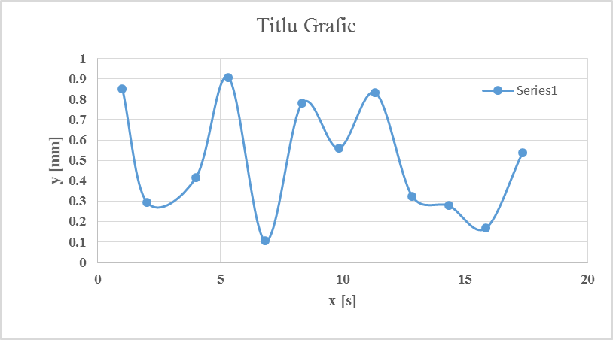
Figure 1: Brief description of the figure.

Formatting the tables
Tables containing data on experimental parameters or other information will be formatted according to the example given in Table 1. The table will be aligned centered.

Table 1. Brief description of the data

Nr. experiment | x | y | z
1 | 0 | 0 | 0
2 | -1 | -1 | 0
3 | 0 | 1 | -1
4 | 0 | 0 | 0

Introduction of equations
To insert mathematical equations and expressions is necessary to use Equation Editor in Word. It allows for formatting of characters and symbols that are used for writing equations. The equations will be placed with centered alignment and being numbered.
The numbering is done by including the equation number in brackets. Equation number will be used in the text when conducting a reference or comment thereon (see Eq. 1).

(1)
(2)

It is recommended to use the tab key to align the text. Setting the equation in Equation Editor is made like in Figure 2 (Size->Define Size menu).

Figure 2: Setting the equation in Equation Editor

Format text using predefined styles
This template document defines several text styles that will help you format the paper. These built-in styles can be seen at the top of the Word application in the Home section (see Figure 3).

Figure 3: The built-in styles that will help you format the paper.

The built-in styles are as follows:

Title Article– formats the title of the paper;
Authors-Coordinators-Affiliation– formats the authors and their affiliation;
Title-Abstract-Keywords– formats the ABSTRACT and the KEYWORD;
Text-Abstract – formats the text in the abstract and also the keywords;
Title-Section– numbers and formats the title of a section of the article;
Title-Subsection- numbers and formats the title of a subsection of the article;
Text Paper– formats the body text in the paper;
Text-Figure-Tabel– to format a table title and description of a figure.
Ecuation – to format equations;
References – numbers and format the references.

results and conclusions
The information presented here will be intended to synthesize the main findings and conclusions presented in this article.

references

- Conslik, J., Optimal Response Surface Design in Monte Carlo Sampling Experiments, Annals of Economic and Social Measurement, Vol. 3, Nr. 3, pp. 463-473, 1974.
- Myers, R., Montgomery, D., Anderson-Cook, C.M., Response Surface Methodology: Process and Product Optimization Using Designed Experiments, Wiley, ISBN: 978-0-470-17446-3, 2009.
- Taloi, D., Florian, E., Bratu, C., Berceanu, E., Optimizarea proceselor metalurgice, Editura Didactică şi Pedagogică Bucureşti, 1983.
- Nicolet, C., Zobeiri, A. Maruzewski, P., Avellan, F., On the upper part load vortex rope in Francis turbine: Experimental investigation, in: IOP Conference Series Earth and Environmental Science, Vol. 12, pp. 012053, 2010.
- http://www.minitab.com/en-US/default.aspx

